DehuTech™ 500 Desiccant Dehumidifier

#### **DehuTech™** desiccant (adsorption) dehumidifiers are developed, designed and produced to meet the highest demands for high capacity, low energy consumption, reliability and simple maintenance.

All desiccant dehumidifiers are fitted with a high performance adsorption rotor that is washable, incombustible, chemically inert and mechanically stable.

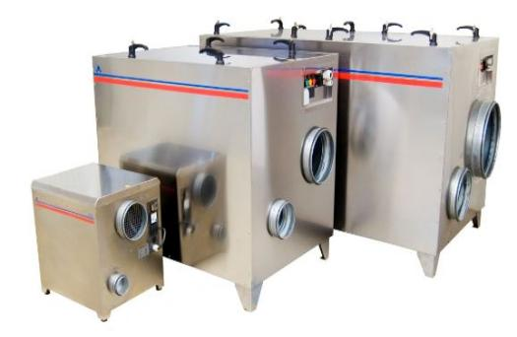

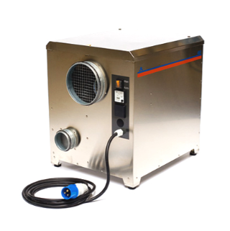

**DehuTech™ 500** desiccant dehumidifier is delivered as a complete unit with fans, filter, rotor and controls. The dehumidifier is ready for site installation and connection to standard-size ducting and electrical mains (1 x 230V 50Hz).

Features

* Sturdy housing in stainless steel.
* Low weight.
* PTC (Positive Temperature Control) Reactivation heater, eliminates the risk for overheating and allows stepless capacity control.
* The desiccant rotor, including its transmission element and fan, can be easily lifted out of the housing for external inspection and service.

Accessories for DehuTech™ 400

* External humidistat connection.
* Air cooled condenser
* Floor stand.
* Wall bracket

